Class Diagram

A report describing the Class Diagrams for the Network Appliance Service Utilisation Framework

Version: 0.1

By

Paul Fergus

Supervised by

Dr. Martin Hanneghan and Prof. Madjid Merabti

Networked Appliances Lab
School of Computing and Mathematical Sciences
Liverpool John Moores University

Table of Contents
Table of Contents ii
Table of Figures viii
1 Introduction 2
1.1 Sections 2
1.2 Release Information 2
1.3 Reader Level 2
1.4 The Specification Process 3
1.5 Version Information 3
1.6 Referenced Documents 3
2 The Unified Modelling Language – Class Diagrams Overview 4
2.1 Class Diagrams 4
2.1.1 Creating Manageable Class Diagrams 4
3 Class Diagram: Distributed Semantic Unstructured Services (DiSUS) Manager 5
3.1 Description 5
3.2 Issues 5
3.3 Requirements 5
3.4 Assumptions 5
3.5 Attributes 5
3.6 Methods 5
3.7 Extensions 5
4 Class Diagram: P2P Implementation 6
4.1 Description 6
4.2 Issues 6
4.3 Requirements 6
4.4 Assumptions 7
4.5 Attributes 7
4.6 Methods 7
4.7 Extensions 7
5 Class Diagram: Discovery Service 8
5.1 Description 8
5.2 Issues 8
5.3 Requirements 8
5.4 Assumptions 8
5.5 Attributes 9
5.6 Methods 9
5.7 Extensions 9
6 Class Diagram: Endpoint Service 10
6.1 Description 10
6.2 Issues 10
6.3 Requirements 10
6.4 Assumptions 10
6.5 Attributes 10
6.6 Methods 10
6.7 Extensions 10
7 Class Diagram: Endpoint 11
7.1 Description 11
7.2 Issues 11
7.3 Requirements 11
7.4 Assumptions 11
7.5 Attributes 11
7.6 Methods 11
7.7 Extensions 11
8 Class Diagram: Service Implementation Manager 12
8.1 Description 12
8.2 Issues 12
8.3 Requirements 12
8.4 Assumptions 12
8.5 Attributes 12
8.6 Methods 12
8.7 Extensions 12
9 Class Diagram: Peer Service Manager 13
9.1 Description 13
9.2 Issues 13
9.3 Requirements 13
9.4 Assumptions 13
9.5 Attributes 13
9.6 Methods 13
9.7 Extensions 13
10 Class Diagram: Peer Service Advertisement 14
10.1 Description 14
10.2 Issues 14
10.3 Requirements 14
10.4 Assumptions 14
10.5 Attributes 14
10.6 Methods 14
10.7 Extensions 14
11 Class Diagram: Service Class Advertisement 15
11.1 Description 15
11.2 Issues 15
11.3 Requirements 15
11.4 Assumptions 15
11.5 Attributes 16
11.6 Methods 16
11.7 Extensions 16
12 Class Diagram: Service Specification Advertisement 17
12.1 Description 17
12.2 Issues 17
12.3 Requirements 17
12.4 Assumptions 17
12.5 Attributes 17
12.6 Methods 18
12.7 Extensions 18
13 Class Diagram: Service Implementation Advertisement 19
13.1 Description 19
13.2 Issues 19
13.3 Requirements 20
13.4 Assumptions 20
13.5 Attributes 20
13.6 Methods 20
13.7 Extensions 20
14 Class Diagram: Service Ontology Model 21
14.1 Description 21
14.2 Issues 21
14.3 Requirements 21
14.4 Assumptions 21
14.5 Attributes 21
14.6 Methods 21
14.7 Extensions 22
15 Class Diagram: Service Profile Ontology Model 23
15.1 Description 23
15.2 Issues 23
15.3 Requirements 23
15.4 Assumptions 23
15.5 Attributes 23
15.6 Methods 23
15.7 Extensions 23
16 Class Diagram: Service Process Ontology Model 24
16.1 Description 24
16.2 Issues 24
16.3 Requirements 24
16.4 Assumptions 24
16.5 Attributes 24
16.6 Methods 24
16.7 Extensions 24
17 Class Diagram: Service Grounding Ontology Model 25
17.1 Description 25
17.2 Issues 25
17.3 Requirements 25
17.4 Assumptions 25
17.5 Attributes 25
17.6 Methods 25
17.7 Extensions 25
18 Class Diagram: Service Interface Model 26
18.1 Description 26
18.2 Issues 26
18.3 Requirements 26
18.4 Assumptions 26
18.5 Attributes 26
18.6 Methods 26
18.7 Extensions 27
19 Class Diagram: Device Capability Advertisement 28
19.1 Description 28
19.2 Issues 28
19.3 Requirements 28
19.4 Assumptions 28
19.5 Attributes 28
19.6 Methods 28
19.7 Extensions 28
20 Class Diagram: Distributed Emergent Semantics (DistrES) Service 29
20.1 Description 29
20.2 Issues 29
20.3 Requirements 29
20.4 Assumptions 29
20.5 Attributes 29
20.6 Methods 29
20.7 Extensions 29
21 Class Diagram: Concept Extractor Engine Service 30
21.1 Description 30
21.2 Issues 30
21.3 Requirements 30
21.4 Assumptions 30
21.5 Attributes 30
21.6 Methods 30
21.7 Extensions 31
22 Class Diagram: Evolutionary Pattern Extraction Engine Service 32
22.1 Description 32
22.2 Issues 32
22.3 Requirements 32
22.4 Assumptions 32
22.5 Attributes 33
22.6 Methods 33
22.7 Extensions 33
23 Class Diagram: DistrES Ontology 34
23.1 Description 34
23.2 Issues 34
23.3 Requirements 34
23.4 Assumptions 34
23.5 Attributes 34
23.6 Methods 34
23.7 Extensions 35
24 Class Diagram: Semantic Interoperability and Signature Matching (SISM) Service 36
24.1 Description 36
24.2 Issues 36
24.3 Requirements 36
24.4 Assumptions 36
24.5 Attributes 36
24.6 Methods 37
24.7 Extensions 37
25 Class Diagram: Abstract Matcher Service 38
25.1 Description 38
25.2 Issues 38
25.3 Requirements 38
25.4 Assumptions 38
25.5 Attributes 38
25.6 Methods 39
25.7 Extensions 39
26 Class Diagram: Concrete Matcher Service 40
26.1 Description 40
26.2 Issues 40
26.3 Requirements 40
26.4 Assumptions 40
26.5 Attributes 40
26.6 Methods 40
26.7 Extensions 41
27 References 42

Table of Figures
Figure 1 UML Notation for a Class Diagram 4
Figure 2 Distributed Semantic Unstructured Services Manager 5
Figure 3 P2P Implementation Classes 6
Figure 4 Discovery Service 8
Figure 5 Endpoint Service 10
Figure 6 Endpoint 11
Figure 7 Service Implementation Manager 12
Figure 8 Peer Service Manager 13
Figure 9 Peer Service Advertisement 14
Figure 10 Service Class Advertisement 15
Figure 11 Service Specification Advertisement 17
Figure 12 Service Implementation Advertisement 19
Figure 13 Service Ontology Model 21
Figure 14 Service Profile Ontology Model 23
Figure 15 Service Process Ontology Model 24
Figure 16 Service Grounding Ontology Model 25
Figure 17 Service Interface Model 26
Figure 18 Device Capability Advertisement 28
Figure 19 Distributed Emergent Semantics Service 29
Figure 20 Extractor Engine Service 30
Figure 21 Evolutionary Pattern Extraction Engine Service 32
Figure 22 DistrES Ontology 34
Figure 23 Semantic Interoperability and Signature Matching Service 36
Figure 24 Abstract Matcher Service 38
Figure 25 Concrete Matcher Service 40

ABSTRACT
User demands and technological advances are driving the complex integration between heterogeneous devices, and moving us closer to pervasive and ubiquitous computing environments. The home of the future will include an embedded ‘intelligence’ and accommodate a flexible integration of services to perform functions that are only limited by our imagination. The family car and working environment will be closely integrated allowing the children to watch a movie on digital screens embedded in the back of the driver and passenger seats, by directly streaming the digital content from the DVD player located in the living room of your home. Furthermore you will be able to access and listen to music stored on your MP3 player, which you accordingly left at the office on Friday night, via your wireless enabled headphones, without interrupting the children’s viewing experience. This vision will expose the functionalities offered by devices as independent services [1] and capitalise on advances made in global communications to revolutionise the way we interact with the plethora of devices that surround us.
This vision will require us to perceive and interact with our devices in ways we have never experienced before. The constraints placed on us by manufacturers and service providers will become a thing of the past as the flexible and seamless integration of distributed devices become common place. One of the challenges is to expose the functions offered by devices as services. Manufactures will need to re-engineer most common household appliances and produce solutions that better utilise the functionalities a particular device offers. A framework needs to be developed that allows services to be described using machine-processible semantics enabling devices to make informed decisions regarding the composition process once a potential service has been discovered. The framework needs to utilise advances made in Peer-to-Peer technologies and provide discovery mechanisms that ensure collaborations between devices encompass vocabularies that support machine-level understanding.
In this report we describe how we have designed the Networked Appliance Service Utilisation Framework (NASUF) including the Distributed Semantic Unstructured Services (DiSUS) [2] protocol, the Distributed Emergent Semantics (DistrES) algorithm [3] and the Semantic Interoperability and Signature Matching (SISM) algorithms [4]. We explain how NASUF implements the DiSUS protocol to publish and discover unstructured services within P2P networks, the DistrES algorithm to manage and evolve ontological information over time based on general consensus, and the SISM algorithm to dynamically compose services and resolve terminology differences that occur.

Introduction
The Network Appliance Service Utilisation Framework (NASUF) is designed to allow service-enabled devices to be seamlessly integrated within Peer-to-Peer (P2P) networks. Once these devices have been deployed they can expose the functions they provide as independent services, which are described and discovered using machine-processable semantics.
The framework is flexible and does not place any constraints on the underlying technologies used. It is designed to provide a set of core interfaces that must be implemented in order to enable services to be effectively described and discovered within P2P networks. This framework does not place any constraints on the underlying communication protocols used or the P2P technology used to deploy devices and the services they provide. Furthermore it does not place any constraints on the service technology used allowing a plethora of different services to be used and integrated with relative ease.
This is the first release of this specification and is still a work in progress. Its primary goal is to define a set of generic interfaces that support the above mentioned requirements.

Sections
This document is split into two sections. The first section provides a conceptual overview of UML [5] and Class Diagram modelling within UML. It describes the vocabulary used and provides some simple illustrations that show a simple Class Diagram. The second section provides a detailed list of all the Class Diagrams used to define this framework.

Release Information
This document is a work in progress and is an initial first draft. This release is an unstable release that is designed to prompt discussions in order to refine our overall framework design. Its primary function is to highlight the functionalities this framework provides and to prompt further investigation.

Reader Level
This document can be used by a number of readers, who are concerned with the framework from a number of different viewpoints.
- Service Developers
- Distributed Computing Developers
- Semantic Web Developers
- Networked Appliance Developers
- Framework Designers
- Enterprise Architects
This specification assumes that the reader is converse with UML and more specifically Class Diagram design. The specification is language and protocol agnostic and could be used to implement service-enabled networked appliances using a number of different languages, which implement a number of different communication protocols.

The Specification Process
The specification process is performed as part of a PhD project, with a number of researchers and Academic staff involved in its creation. The specification is reviewed subject matter experts within the fields of UML modelling, P2P technologies, Semantic Web technologies and Networked Appliances. We hope that as this specification evolves it will be opened up to a much wider audience, whereby contributions can be made by a number of expert groups.
The current process involves the framework design using a number of UML models. At predetermined millstones the designs are submitted to the subject matter experts, which are then evaluated. Any changes are performed and all design decisions are challenged. This process continues until defined work packages are completed.

Version Information
This version is not designed to be used for implementations. This version is designed to prompt discussion on this framework design to ensure that the framework captures all the required functionality.

Referenced Documents
The following documents should be read in conjunction with this Class Diagram document.
- NASUF – Use Case Diagram 1.0.doc
- NASUF – Activity Diagram 1.0.doc
- NASUF – Sequence Diagram 1.0.doc

The Unified Modelling Language – Class Diagrams Overview
This document defines all the Class Diagrams that exist within the NASUF framework. As a result this section only concerns itself with Class Diagram modelling. Other UML models are discussed in relevant documents that should be read in conjunction with this document as detailed in Section 1.6 above.

Class Diagrams
The primary goal of Class Diagrams is to show the fixed structures of classes, objects, attributes, operations, associations, generalisations and aggregations. As such larger projects may required a significant number of classes, consequently Class Diagrams must be separated and kept simple otherwise they become confusing and difficult to follow. When Class Diagrams are split into smaller manageable pieces it is important that consistency is maintained throughout all the Class Diagrams within the system.

Creating Manageable Class Diagrams
The main point to note is that larger diagrams will confuse project members and they will be difficult to understand. The main idea behind UML is to effectively communicate ideas from a number of perspectives therefore your diagrams will have more chance of success if they are broken down into smaller more understandable pieces.
It is best to begin by creating a top-level diagram (no more than 15 classes) that provides an overview of the most important classes – these will be the most important objects to your business. Once the top-level diagram has been created begin to create second-level diagrams for each of the key classes in the top-level diagram. In second level diagrams you should add the attributes, operations, including other required classes needed and there corresponding associations. When you have a significant inheritance hierarchy, place the superclass and its subclasses in a separate diagram. If any the second-level diagrams are too complex (contain more than 10 classes) then a third-level diagram should be created.

Figure 1 UML Notation for a Class Diagram

Class Diagram: Distributed Semantic Unstructured Services (DiSUS) Manager

Description
This Class Diagram illustrates the classes used to implement distributed semantic unstructured services within this framework. The Class Diagram is illustrated in Figure 2.
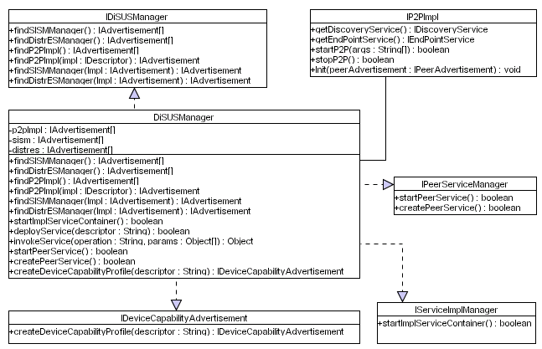
Figure 2 Distributed Semantic Unstructured Services Manager

Issues
The issues associated with the Class Diagram are not known at this stage.

Requirements
The requirements for this Class Diagram are not known at this stage of the design.

Assumptions
The assumptions for this Class Diagram are not known at this stage of the design.

Attributes
Need to do

Methods
Need to do

Extensions
There are no known extensions for this Class Diagram at this stage of the design.

Class Diagram: P2P Implementation

Description
This Class Diagram illustrates what the required P2P implementation classes required within this framework. The Class Diagram is illustrated in Figure 3.
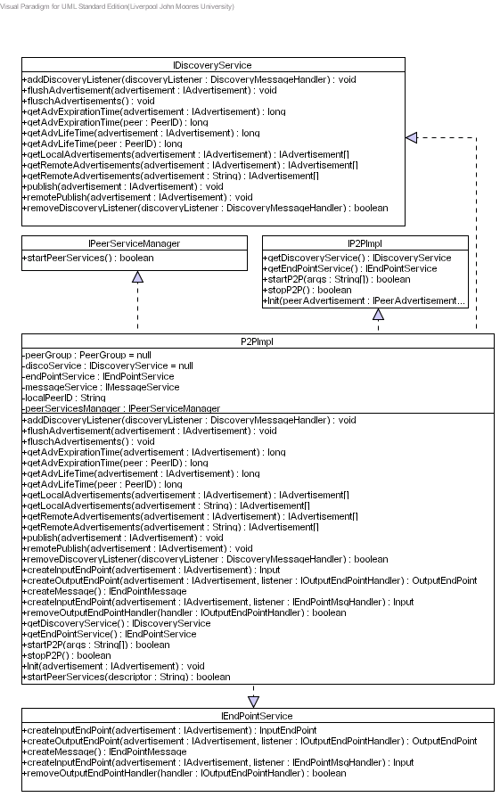
Figure 3 P2P Implementation Classes

Issues
The issues associated with the Class Diagram are not known at this stage.

Requirements
The requirements for this Class Diagram are not known at this stage of the design.

Assumptions
The assumptions for this Class Diagram are not known at this stage of the design.

Attributes
Need to do

Methods
Need to do

Extensions
There are no known extensions for this Class Diagram at this stage of the design.

Class Diagram: Discovery Service

Description
This Class Diagram illustrates the classes required for the discovery service used within this framework. The Class Diagram is illustrated in Figure 4.
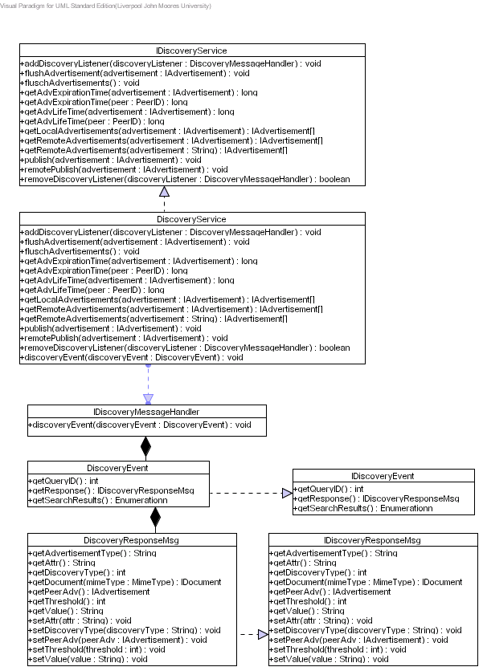
Figure 4 Discovery Service

Issues
The issues associated with the Class Diagram are not known at this stage.

Requirements
The requirements for this Class Diagram are not known at this stage of the design.

Assumptions
The assumptions for this Class Diagram are not known at this stage of the design.

Attributes
Need to do

Methods
Need to do

Extensions
There are no known extensions for this Class Diagram at this stage of the design.

Class Diagram: Endpoint Service

Description
This Class Diagram illustrates the classes required for the endpoint service used within this framework. The Class Diagram is illustrated in Figure 5.
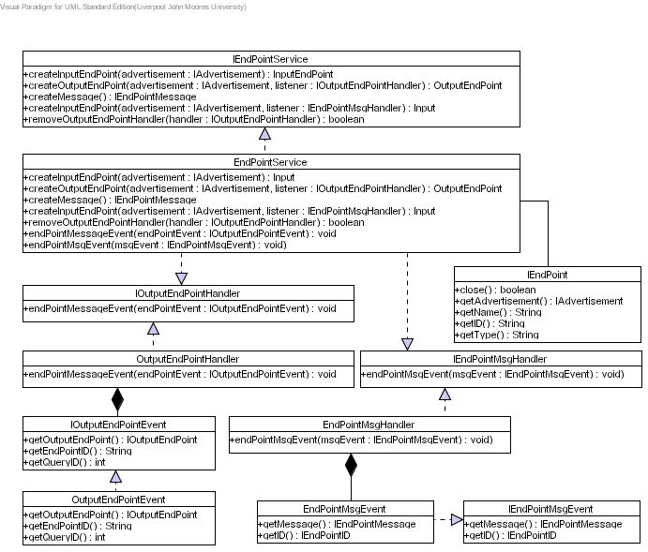
Figure 5 Endpoint Service

Issues
The issues associated with the Class Diagram are not known at this stage.

Requirements
The requirements for this Class Diagram are not known at this stage of the design.

Assumptions
The assumptions for this Class Diagram are not known at this stage of the design.

Attributes
Need to do

Methods
Need to do

Extensions
There are no known extensions for this Class Diagram at this stage of the design.

Class Diagram: Endpoint

Description
This Class Diagram illustrates the classes required for the Endpoints using within this framework. The Class Diagram is illustrated in Figure 6.
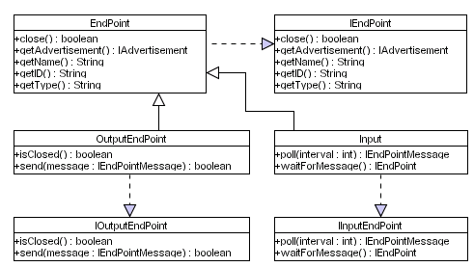
Figure 6 Endpoint

Issues
The issues associated with the Class Diagram are not known at this stage.

Requirements
The requirements for this Class Diagram are not known at this stage of the design.

Assumptions
The assumptions for this Class Diagram are not known at this stage of the design.

Attributes
Need to do

Methods
Need to do

Extensions
There are no known extensions for this Class Diagram at this stage of the design.

Class Diagram: Service Implementation Manager

Description
This Class Diagram illustrates the classes required for the implementation service manager within this framework. The Class Diagram is illustrated in Figure 7.
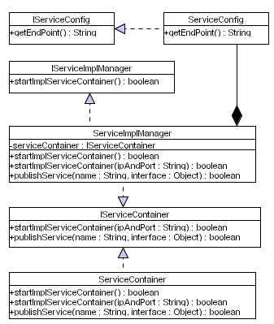
Figure 7 Service Implementation Manager

Issues
The issues associated with the Class Diagram are not known at this stage.

Requirements
The requirements for this Class Diagram are not known at this stage of the design.

Assumptions
The assumptions for this Class Diagram are not known at this stage of the design.

Attributes
Need to do

Methods
Need to do

Extensions
There are no known extensions for this Class Diagram at this stage of the design.

Class Diagram: Peer Service Manager

Description
This Class Diagram illustrates the classes required for the Peer Service Manager within this framework. The Class Diagram is illustrated in Figure 8.
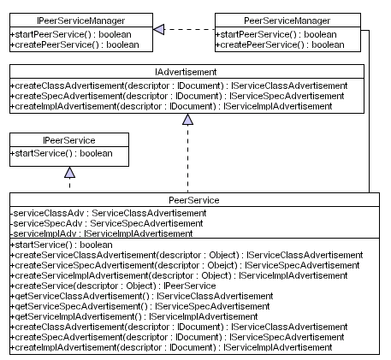
Figure 8 Peer Service Manager

Issues
The issues associated with the Class Diagram are not known at this stage.

Requirements
The requirements for this Class Diagram are not known at this stage of the design.

Assumptions
The assumptions for this Class Diagram are not known at this stage of the design.

Attributes
Need to do

Methods
Need to do

Extensions
There are no known extensions for this Class Diagram at this stage of the design.

Class Diagram: Peer Service Advertisement

Description
This Class Diagram illustrates the required classes to create peer service advertisements within this framework. The Class Diagram is illustrated in Figure 9.
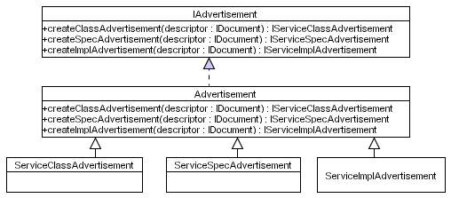
Figure 9 Peer Service Advertisement

Issues
The issues associated with the Class Diagram are not known at this stage.

Requirements
The requirements for this Class Diagram are not known at this stage of the design.

Assumptions
The assumptions for this Class Diagram are not known at this stage of the design.

Attributes
Need to do

Methods
Need to do

Extensions
There are no known extensions for this Class Diagram at this stage of the design.

Class Diagram: Service Class Advertisement

Description
This Class Diagram illustrates the classes required to create a service class advertisement within this framework. The Class Diagram is illustrated in Figure 10.
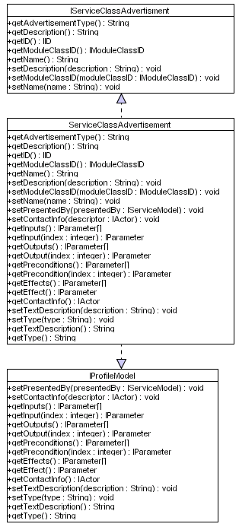
Figure 10 Service Class Advertisement

Issues
The issues associated with the Class Diagram are not known at this stage.

Requirements
The requirements for this Class Diagram are not known at this stage of the design.

Assumptions
The assumptions for this Class Diagram are not known at this stage of the design.

Attributes
Need to do

Methods
Need to do

Extensions
There are no known extensions for this Class Diagram at this stage of the design.

Class Diagram: Service Specification Advertisement

Description
This Class Diagram illustrates the required classes to create a service specification advertisement within this framework. The Class Diagram is illustrated in Figure 11.
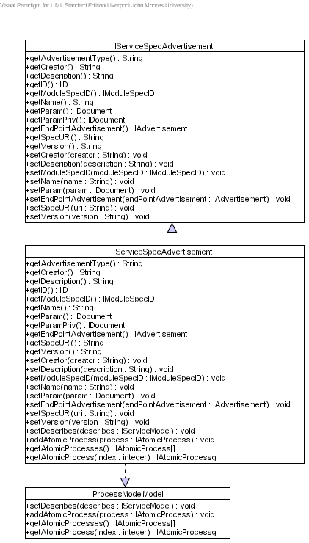
Figure 11 Service Specification Advertisement

Issues
The issues associated with the Class Diagram are not known at this stage.

Requirements
The requirements for this Class Diagram are not known at this stage of the design.

Assumptions
The assumptions for this Class Diagram are not known at this stage of the design.

Attributes
Need to do

Methods
Need to do

Extensions
There are no known extensions for this Class Diagram at this stage of the design.

Class Diagram: Service Implementation Advertisement

Description
This Class Diagram illustrates the required classes to create a service implementation service within this framework. The Class Diagram is illustrated in Figure 12.
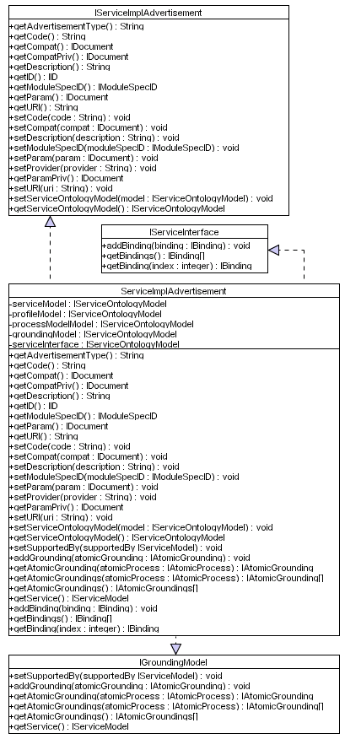
Figure 12 Service Implementation Advertisement

Issues
The issues associated with the Class Diagram are not known at this stage.

Requirements
The requirements for this Class Diagram are not known at this stage of the design.

Assumptions
The assumptions for this Class Diagram are not known at this stage of the design.

Attributes
Need to do

Methods
Need to do

Extensions
There are no known extensions for this Class Diagram at this stage of the design.

Class Diagram: Service Ontology Model

Description
This Class Diagram illustrates the required classes to service ontology model within this framework. The Class Diagram is illustrated in Figure 13.
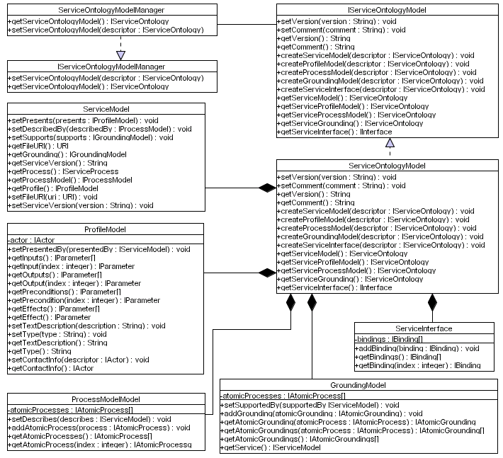
Figure 13 Service Ontology Model

Issues
The issues associated with the Class Diagram are not known at this stage.

Requirements
The requirements for this Class Diagram are not known at this stage of the design.

Assumptions
The assumptions for this Class Diagram are not known at this stage of the design.

Attributes
Need to do

Methods
Need to do

Extensions
There are no known extensions for this Class Diagram at this stage of the design.

Class Diagram: Service Profile Ontology Model

Description
This Class Diagram illustrates the required classes need to create a service profile ontology model within this framework. The Class Diagram is illustrated in Figure 14.
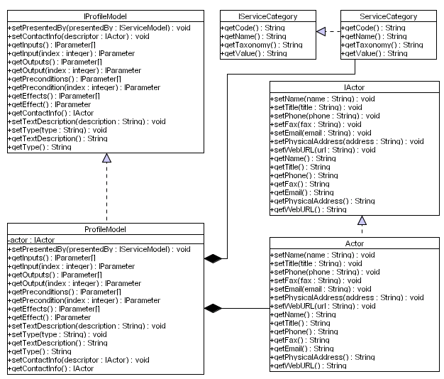
Figure 14 Service Profile Ontology Model

Issues
The issues associated with the Class Diagram are not known at this stage.

Requirements
The requirements for this Class Diagram are not known at this stage of the design.

Assumptions
The assumptions for this Class Diagram are not known at this stage of the design.

Attributes
Need to do

Methods
Need to do

Extensions
There are no known extensions for this Class Diagram at this stage of the design.

Class Diagram: Service Process Ontology Model

Description
This Class Diagram illustrates the classes required to create a service process ontology model within this framework. The Class Diagram is illustrated in Figure 15.
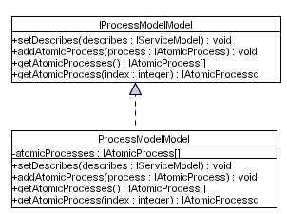
Figure 15 Service Process Ontology Model

Issues
The issues associated with the Class Diagram are not known at this stage.

Requirements
The requirements for this Class Diagram are not known at this stage of the design.

Assumptions
The assumptions for this Class Diagram are not known at this stage of the design.

Attributes
Need to do

Methods
Need to do

Extensions
There are no known extensions for this Class Diagram at this stage of the design.

Class Diagram: Service Grounding Ontology Model

Description
This Class Diagram illustrates the classes required to create a service process ontology model within this framework. The Class Diagram is illustrated in Figure 16.
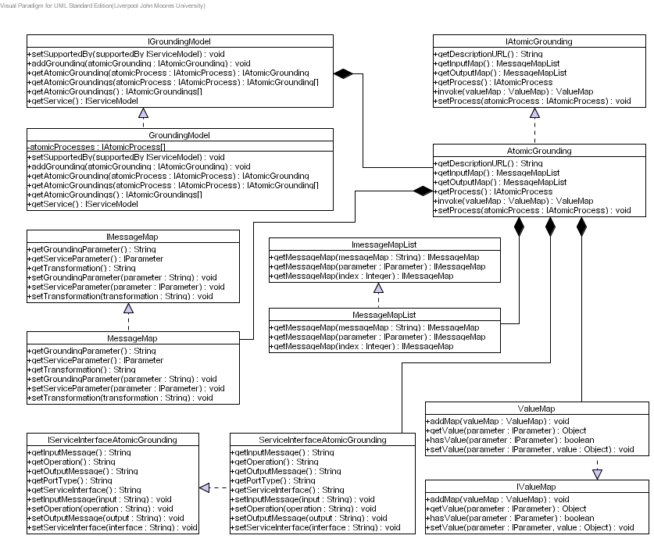
Figure 16 Service Grounding Ontology Model

Issues
The issues associated with the Class Diagram are not known at this stage.

Requirements
The requirements for this Class Diagram are not known at this stage of the design.

Assumptions
The assumptions for this Class Diagram are not known at this stage of the design.

Attributes
Need to do

Methods
Need to do

Extensions
There are no known extensions for this Class Diagram at this stage of the design.

Class Diagram: Service Interface Model

Description
This Class Diagram illustrates the classes required to create a service interface model within this framework. The Class Diagram is illustrated in Figure 17.
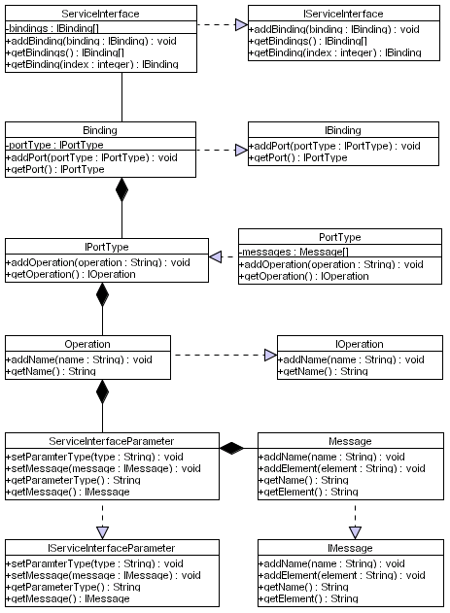
Figure 17 Service Interface Model

Issues
The issues associated with the Class Diagram are not known at this stage.

Requirements
The requirements for this Class Diagram are not known at this stage of the design.

Assumptions
The assumptions for this Class Diagram are not known at this stage of the design.

Attributes
Need to do

Methods
Need to do

Extensions
There are no known extensions for this Class Diagram at this stage of the design.

Class Diagram: Device Capability Advertisement

Description
This Class Diagram illustrates the classes required to create a device capability advertisement within this framework. The Class Diagram is illustrated in Figure 18.
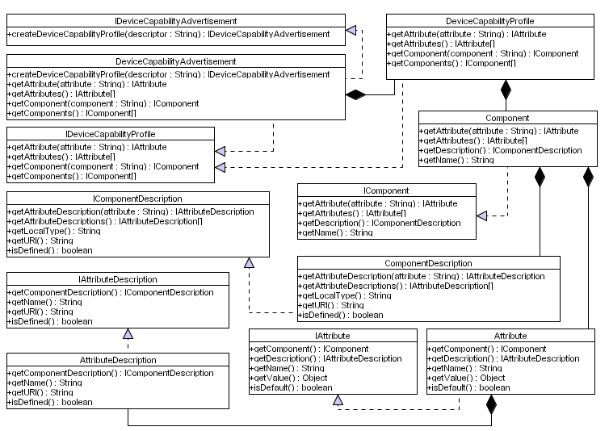
Figure 18 Device Capability Advertisement

Issues
The issues associated with the Class Diagram are not known at this stage.

Requirements
The requirements for this Class Diagram are not known at this stage of the design.

Assumptions
The assumptions for this Class Diagram are not known at this stage of the design.

Attributes
Need to do

Methods
Need to do

Extensions
There are no known extensions for this Class Diagram at this stage of the design.

Class Diagram: Distributed Emergent Semantics (DistrES) Service

Description
This Class Diagram illustrates the classes required for implementing distributed emergent semantics within this framework. The Class Diagram is illustrated in Figure 19.
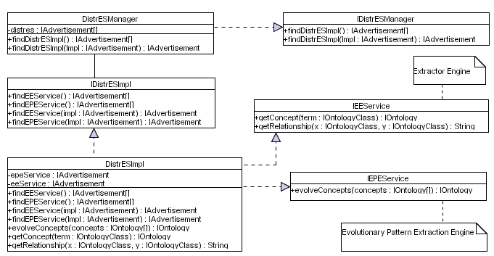
Figure 19 Distributed Emergent Semantics Service

Issues
The issues associated with the Class Diagram are not known at this stage.

Requirements
The requirements for this Class Diagram are not known at this stage of the design.

Assumptions
The assumptions for this Class Diagram are not known at this stage of the design.

Attributes
Need to do

Methods
Need to do

Extensions
There are no known extensions for this Class Diagram at this stage of the design.

Class Diagram: Concept Extractor Engine Service

Description
This Class Diagram illustrates the classes required for the extracting concepts from the knowledge base within this framework. The Class Diagram is illustrated in Figure 20.
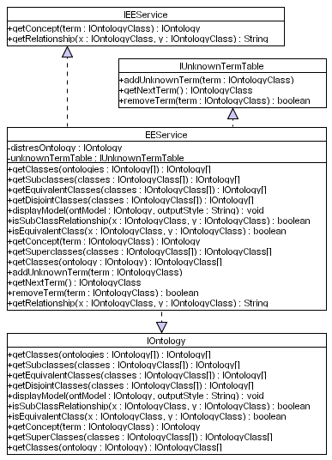
Figure 20 Extractor Engine Service

Issues
The issues associated with the Class Diagram are not known at this stage.

Requirements
The requirements for this Class Diagram are not known at this stage of the design.

Assumptions
The assumptions for this Class Diagram are not known at this stage of the design.

Attributes
Need to do

Methods
Need to do

Extensions
There are no known extensions for this Class Diagram at this stage of the design.

Class Diagram: Evolutionary Pattern Extraction Engine Service

Description
This Class Diagram illustrates the classes required to extract common patterns and evolve knowledge structures within this framework. The Class Diagram is illustrated in Figure 21.
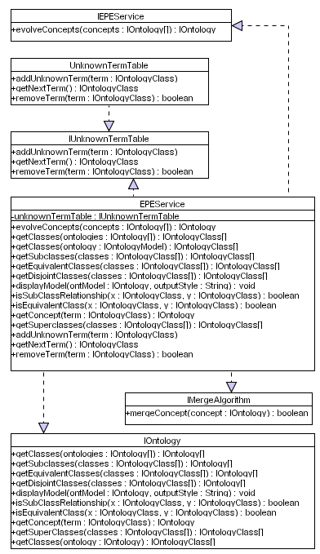
Figure 21 Evolutionary Pattern Extraction Engine Service

Issues
The issues associated with the Class Diagram are not known at this stage.

Requirements
The requirements for this Class Diagram are not known at this stage of the design.

Assumptions
The assumptions for this Class Diagram are not known at this stage of the design.

Attributes
Need to do

Methods
Need to do

Extensions
There are no known extensions for this Class Diagram at this stage of the design.

Class Diagram: DistrES Ontology

Description
This Class Diagram illustrates the classes required to describe ontologies within this framework. The Class Diagram is illustrated in Figure 22.
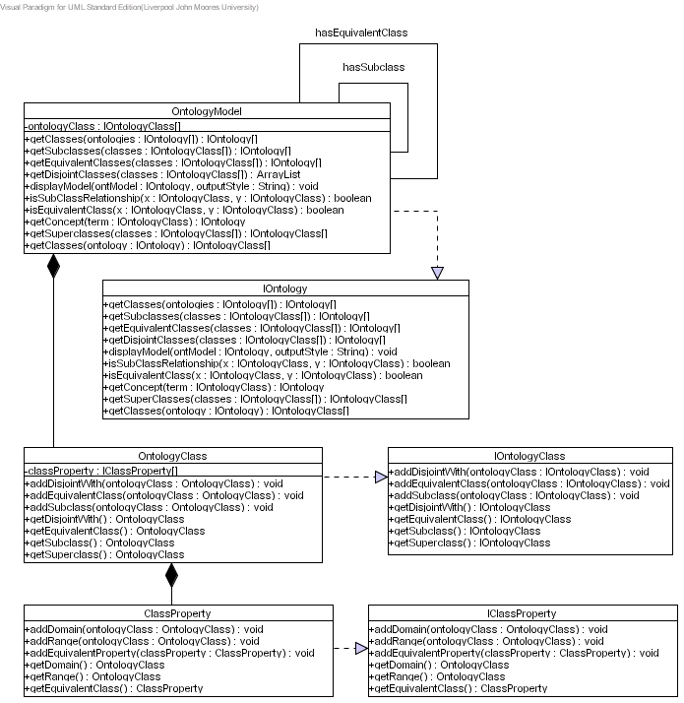
Figure 22 DistrES Ontology

Issues
The issues associated with the Class Diagram are not known at this stage.

Requirements
The requirements for this Class Diagram are not known at this stage of the design.

Assumptions
The assumptions for this Class Diagram are not known at this stage of the design.

Attributes
Need to do

Methods
Need to do

Extensions
There are no known extensions for this Class Diagram at this stage of the design.

Class Diagram: Semantic Interoperability and Signature Matching (SISM) Service

Description
This Class Diagram illustrates the required classes for performing semantic interoperability. The Class Diagram is illustrated in Figure 23.
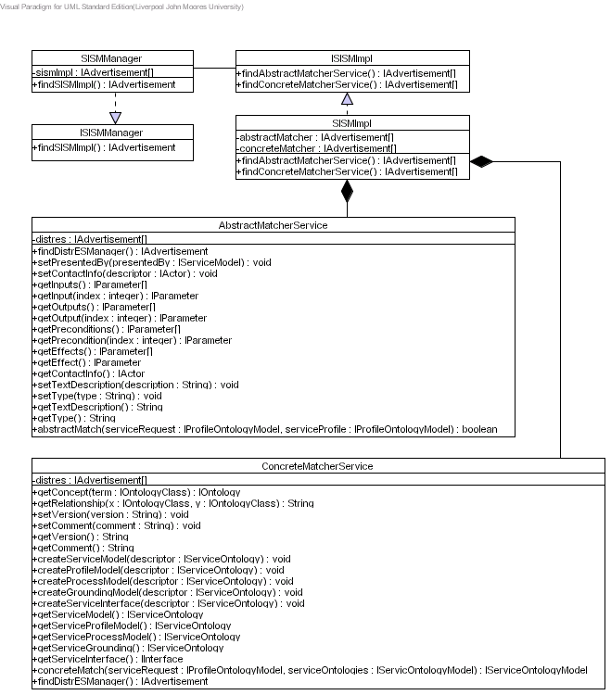
Figure 23 Semantic Interoperability and Signature Matching Service

Issues
The issues associated with the Class Diagram are not known at this stage.

Requirements
The requirements for this Class Diagram are not known at this stage of the design.

Assumptions
The assumptions for this Class Diagram are not known at this stage of the design.

Attributes
Need to do

Methods
Need to do

Extensions
There are no known extensions for this Class Diagram at this stage of the design.

Class Diagram: Abstract Matcher Service

Description
This Class Diagram illustrates the classes required to abstract match service requests with service descriptions. The Class Diagram is illustrated in Figure 24.
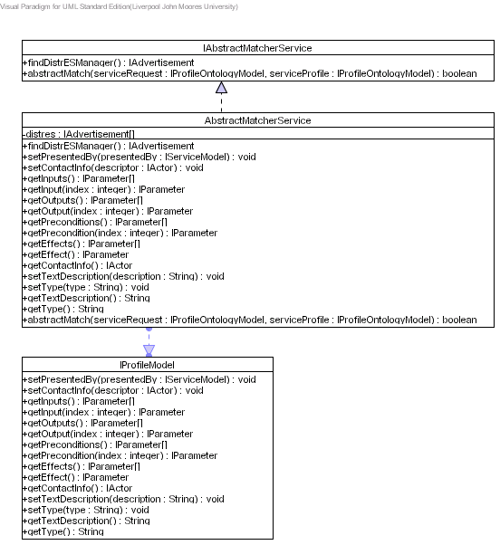
Figure 24 Abstract Matcher Service

Issues
The issues associated with the Class Diagram are not known at this stage.

Requirements
The requirements for this Class Diagram are not known at this stage of the design.

Assumptions
The assumptions for this Class Diagram are not known at this stage of the design.

Attributes
Need to do

Methods
Need to do

Extensions
There are no known extensions for this Class Diagram at this stage of the design.

Class Diagram: Concrete Matcher Service

Description
This Class Diagram illustrates the required classes to concrete match service descriptions with signatures in service interfaces. The Class Diagram is illustrated in Figure 25.
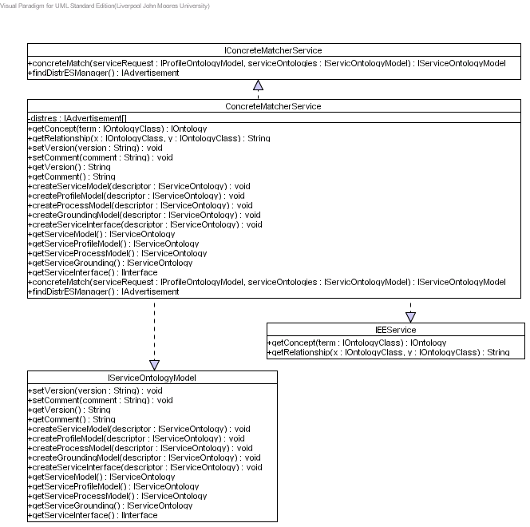
Figure 25 Concrete Matcher Service

Issues
The issues associated with the Class Diagram are not known at this stage.

Requirements
The requirements for this Class Diagram are not known at this stage of the design.

Assumptions
The assumptions for this Class Diagram are not known at this stage of the design.

Attributes
Need to do

Methods
Need to do

Extensions
There are no known extensions for this Class Diagram at this stage of the design.

References

